DiscoTex® Aligned Discontinuous Reinforcement Fabric
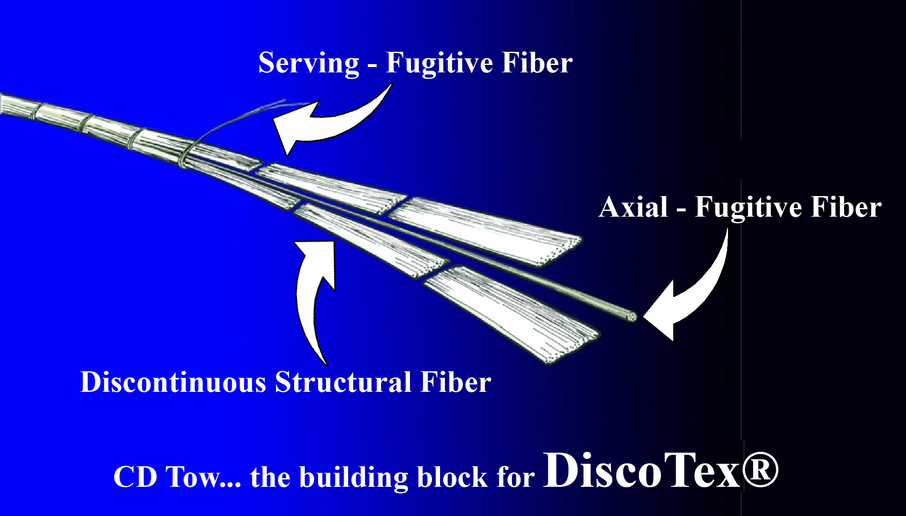
Pepin Associates has developed DiscoTex aligned, discontinuous fiber reinforcement fabric with the use of ONR, AF, DARPA & DAC funds. This conformable fabric is made up of overlapping cut tow segments. These discrete fiber segments are able to stretch in the direction of reinforcement. The ability of this fabric to stretch while remaining aligned allows it to form into complex shapes easily without cutting and darting, saving time during lay-up. A 2011 National Rotorcraft Technology Consortium (NRTC) Program demonstrated the conformability of DiscoTex on actual parts fabricated by three major OEMs & Penn State, resulting in time savings.
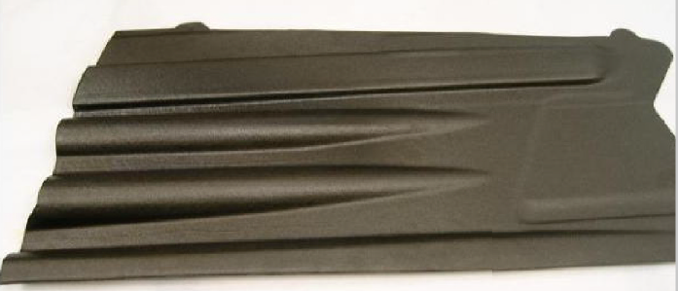
MATERIAL DESCRIPTION
DiscoTex® is woven from a completely discontinuous tow, allowing ease of formability for designs with tight radius curvatures and small weave configurations. It can be fabricated from carbon, fiberglass, quartz or ceramic fiber to suit a variety of applications. Additionally, DiscoTex can enable the design of new complex shapes, unlikely to be designed for manufacture using current continuous materials. Existing legacy components can also be manufactured efficiently, at a reduced cost. DiscoTex fabric can be infused or preimpregnated with a thermoset epoxy resin. Or a thermoplastic matrix can be co-woven into the CD tow which is then woven to form the fabric. For thermoplastic applications, the fabric is heated to melt the matrix material and the part is formed under heat and pressure.
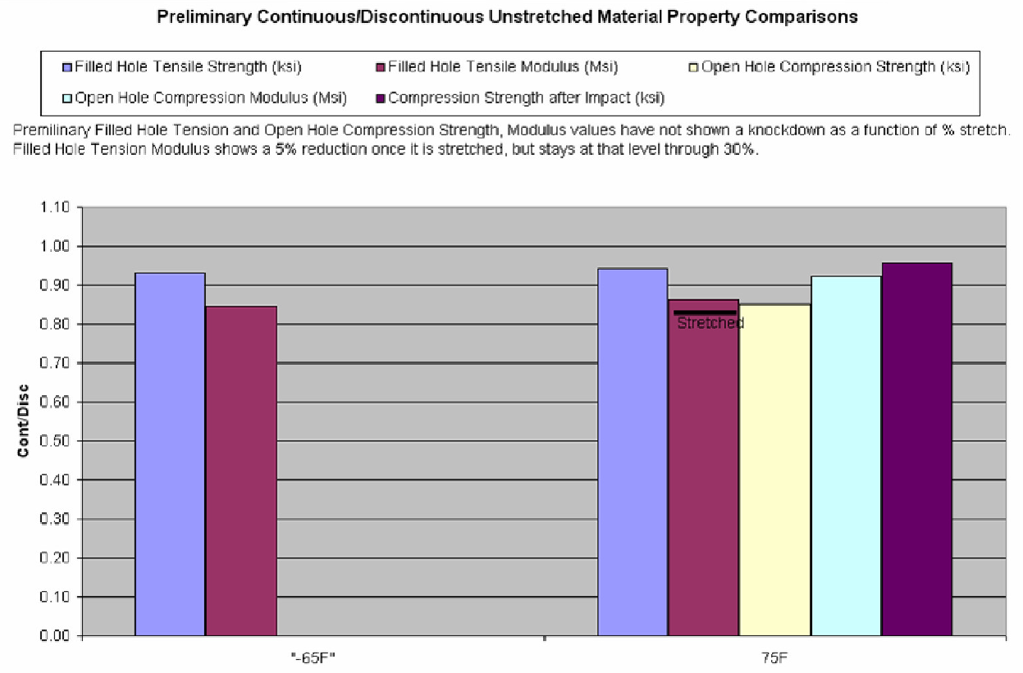

MATERIAL PROPERTY COMPARISONS
Results from mechanical tests conducted at Pepin Associates showed an expected knockdown in matrix-dominated properties such as compression and tension, but unexpectedly showed data comparable to similar continuous systems in pin bearing, inter-laminar shear, inter-laminar tension, and in-plane shear strengths. The preliminary mechanical data trends toward little knockdown between un-stretched and stretched DiscoTex®, which is important for designers and fabricators of complex parts.
REFERENCES
"DiscoTex®: Highly Formable Carbon Fiber Fabric", Elizabeth Goodine, Pepin Associates, Inc., SAMPE 2009.

