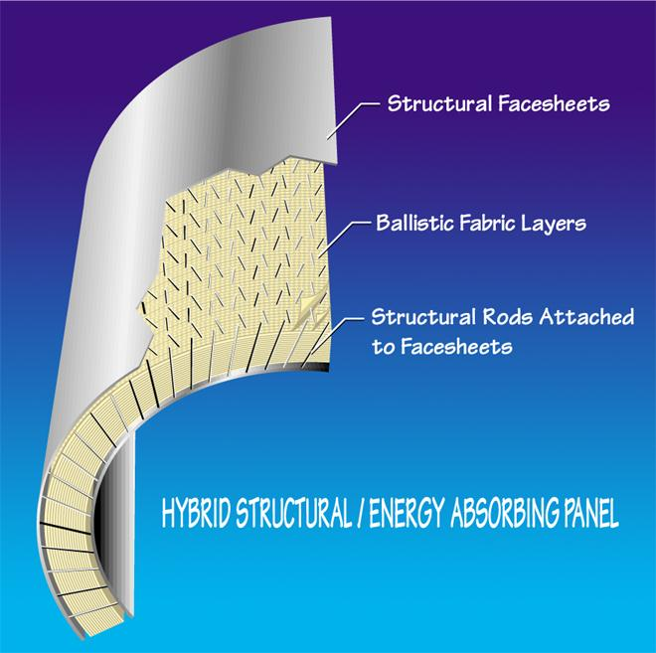**Titanium / Kevlar® Hybrid Sandwich Panel**

*Pepin Associates, Inc. has developed a hybrid sandwich panel which has both structural ballistic integrity. Originating from SBIR-funded research through the FAA, this technology began as a turbine fragment containment ring but is now being developed for use as conformable armor for protecting critical portions of military rotorcraft.*

**PANEL CONFIGURATION**

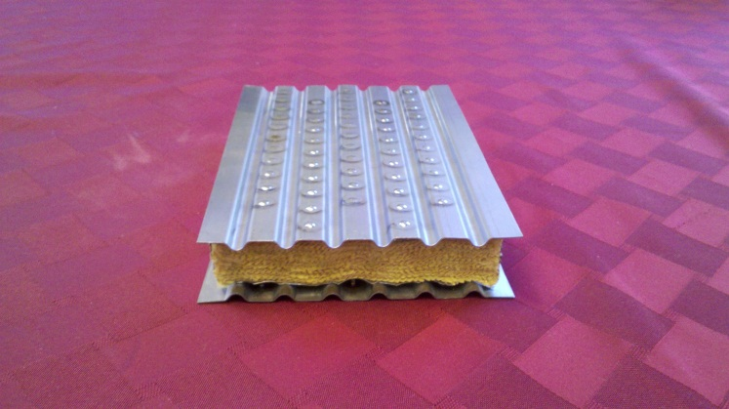Pepin Associates built a number of test panels which have utilized 6/4 titanium sheets, 0.056 inch diameter titanium pins, and Kevlar 29 dry fabric layups. The titanium rods penetrate through the full panel and are laser-welded to the face and back plates. Placed at 45-degree angles in opposing directions per row and filling a 0.5 inch grid pattern, the rods create structural integrity for the panel, allowing it to be used as a portion of a secondary or primary structure rather than as “added weight” to such a structure.

**METHODOLOGY**

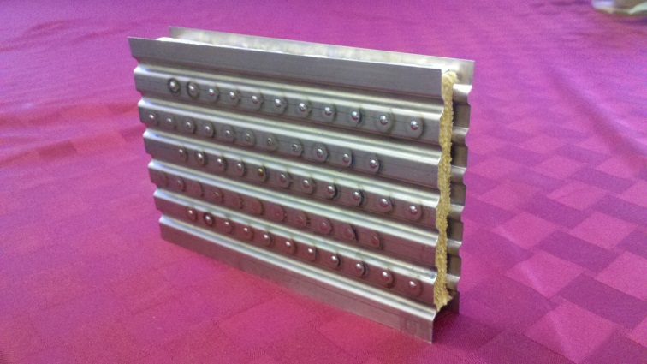Using a metal frame to hold the panel layup in a Bridgeport milling machine, our technician would angle the lay-up to 45-degrees and use the table power feed to push the threaded steel needle through the lay-up. Grid paper was applied to the working face of the panel to guide placement of the rods. A steel needle slightly larger in diameter than the titanium rods would be inserted through the Kevlar layup, immediately followed by a metal rod. The rod tip would have to be milled to a smooth point to allow for penetration of the Kevlar. The rods are inserted every 0.5” with opposing rows of 45°+/- angled insertions. Each row is off-set by 0.25” to place the rods equi-distant from each other throughout the panel. Once the rod has been connected through the face and back plates and through the core material, it is laser welded flat against the outer panels.

**Weight (pounds per square foot)**

The sample panel depicted in the photos above 6.5” x 4.5” x 1.0” and weighs 0.7 lbs, which converts to 3.446 lbs./square foot. Additional ballistic testing is necessary to determine what level of threat this panel would stop, but ceramic panels, such as silicon carbide or boron carbide, may be adhered to the face plate to stop an armor piercing round: such weight additions should keep the panel below 12 lbs./square foot.

**Applications**

This structural panel has possible applications for rotorcraft floors, seat pans, and fuel tank and transmission covers.