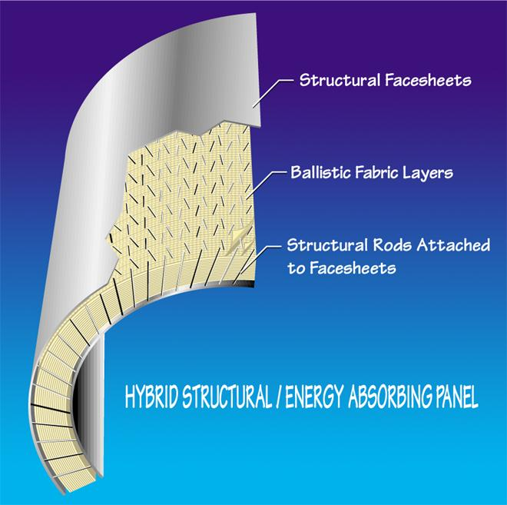**Titanium / Kelvar® Turbine Fragment Containment Ring**

*Pepin Associates, Inc. has developed a containment ring for protecting aircraft or rotorcraft from catastrophic engine failure due to fragment projectiles entering or exiting the engine rotor. The containment ring prevents collapse of the engine housing onto the spinning rotors, which would destroy the rotor and create many more projectiles.*

**PANEL CONFIGURATION**

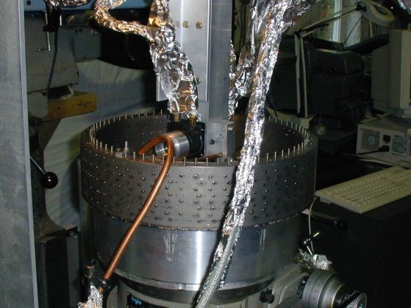Pepin Associates has developed a method of constructing a titanium shell on either side of a dry Kevlar fabric layup, with titanium rods penetrating the full-thickness of the structure. The lay-up uses 6/4 titanium sheets, 0.056 inch diameter titanium pins, and Kevlar 37. The titanium rods are laser-welded to the inner and outer faces of the ring. Placed at 45-degree angles in opposing directions per row and filling a 0.5 inch grid pattern, the rods create structural integrity for the panel.

**MATERIAL SYNERGY**

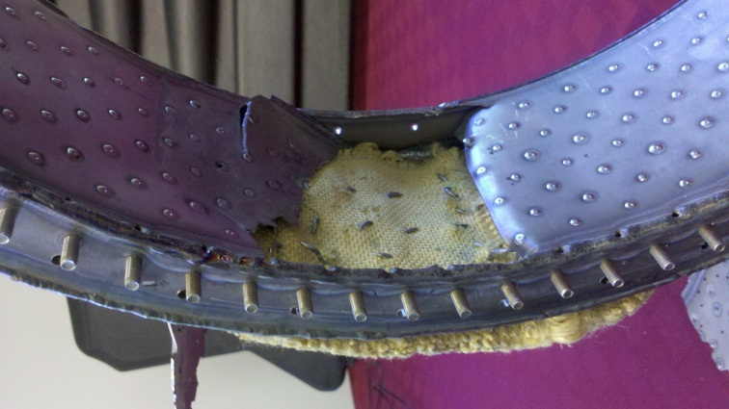Tests have shown some synergy between the two materials. For example, the many rods absorb energy by bending and pulling out of the facesheet joints during fragment impact. Also, the fabric can increase the strength and stiffnessof the panel by supporting the rods laterally thereby delaying buckling of the rods when the panel is loaded in flexure. The hybrid panel also has high toughness when tested statically since, as the rod joints fail, other joints pick up the loading so the structure is very damage tolerant.

**WEIGHT**

The sample panel measuring 6.5” x 4.5” x 1.0” weighs 0.7 lbs, which converts to 3.446 lbs./square foot. Actual weight of a given containment ring would vary with actual material quantities specified.

**APPLICATIONS**

This containment ring has applications for both aircraft and rotorcraft which use rotor engines.

**REFERENCES**

AIAA paper #93-1816, Final Report DOT/FAA/AR-98/22.